Coquille Oregon
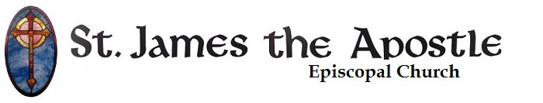
Online Adult Forum
Bishops and Elections
Summer, 2020
Week Two

Was, is, and forever shall be, world without end

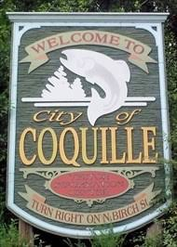
Hi all, and welcome to week two of our study of bishops. This upcoming week are the candidate walkabouts. During this time, our four candidates will be touring the diocese, talking with folks, and answering a number of questions written by the diocese. A lot of these conversations will be posted online for everyone to see. I hope you’ll join the other clergy and the delegates in watching them, praying for the candidates and the diocese, and digging deeper into our life with God in Jesus Christ!

Place, location, where you’re at

Our theme for this week is: location. We’re spending the week introducing the diocese of Oregon to our candidates, and the diocese is more than just the people. Our community not just a people but a people of a particular time and place. If you were able to sit with our candidates and introduce them to Oregon, what would you tell them about? What do you love about this particular part of the world? What would you want to show them?

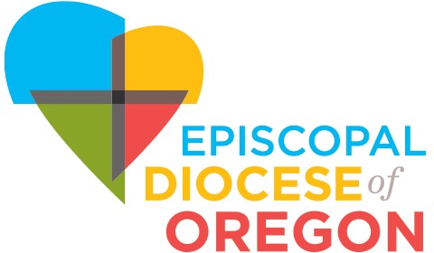
Another way to think of this question is: what about the western half of Oregon shapes you? We’re all shaped by our environment in some way; what’s shaping you and, especially, shaping how you pray? How has the weather here shaped your prayer life? How have the mountains and closeness of the ocean shaped you? How are you, and how is your relationship with God, special because of where you live?

You can answer these questions for yourself while thinking of Oregon, our place here on the south coast, or even just here in Coquille. Or how about your home and garden where you live! This week is to think about all these sorts of questions.

Pew Chats

Our second week of Pew Chats is up. Click on the following week to see it!

https://www.youtube.com/watch?v=nG8apP1sE_Y

Pray

Spend some time praying for our candidates, our diocese, our delegates and clergy. Also say some prayers for our current bishop and his staff. Actually, there are a ton of such prayers in the BCP, starting on page 810. Here are a few good ones:

10. For the Diocese

O God, by your grace you have called us in this Diocese to a
goodly fellowship of faith. Bless our Bishop, Michael,
and other clergy, and all our people. Grant that your Word
may be truly preached and truly heard, your Sacraments
faithfully administered and faithfully received. By your
Spirit, fashion our lives according to the example of your
Son, and grant that we may show the power of your love to
all among whom we live; through Jesus Christ our Lord.
Amen.

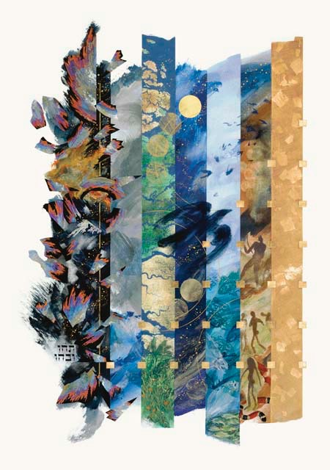
13. For the Election of a Bishop or other Minister

Almighty God, giver of every good gift: Look graciously on
your Church, and so guide the minds of those who shall
choose a bishop for this Diocese,
that we may receive a faithful pastor, who will care for your
people and equip us for our ministries; through Jesus Christ
our Lord. Amen.

Read from the Bible

Land is pretty important in the Bible. God’s covenant is often (though not always) connected to land. And, of course, God was Incarnated as Jesus Christ in a particular time and place. Here are some Bible passages that look at place and location. See if you can think of others!

The Creation: Genesis, chapters 1 and 2
The New Creation: Isaiah 65:17-25
Jesus’ Birth: Luke 2:1-19
The New Heaven and the New Earth: Revelation 21

Reflections

Last week I gave you some Bach to listen to. This week, a “local” artist. David Nevue is a Christian solo pianist from Eugene. Helene and I saw him in concert back when I was at the University of Oregon, and we’ve liked him ever since. His music has a number of moods, but they’re all so full of life and spirit. Here are just three of his albums

For something light and gentle: A Delicate Joy
For something a little darker in tone: Winding Down
For something a bit heavy: Overcome

