Coquille Oregon
Online Adult Forum
Bishops and Elections
Summer, 2020
Week One

Welcome!

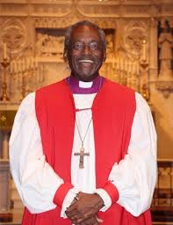
We’re doing a few things differently for our Christian education here at St. James. Since we can’t meet for Soup Suppers, we’re bringing education online! These few pages here are the center of it, but hopefully these ideas, thoughts, and encouragements here will branch off into a week spent in prayer, study, and thoughtfulness.

This week’s theme: leaders and leadership

We’ll be thinking and praying about bishops this month (and especially for our bishop candidates and our electing convention), and so it’s good to start with exactly what bishops are: our spiritual leaders. All our materials are centered around these themes. Give some time to thinking about leadership in the Church but also leadership (in whatever form) in your life as well.

Pew Chats

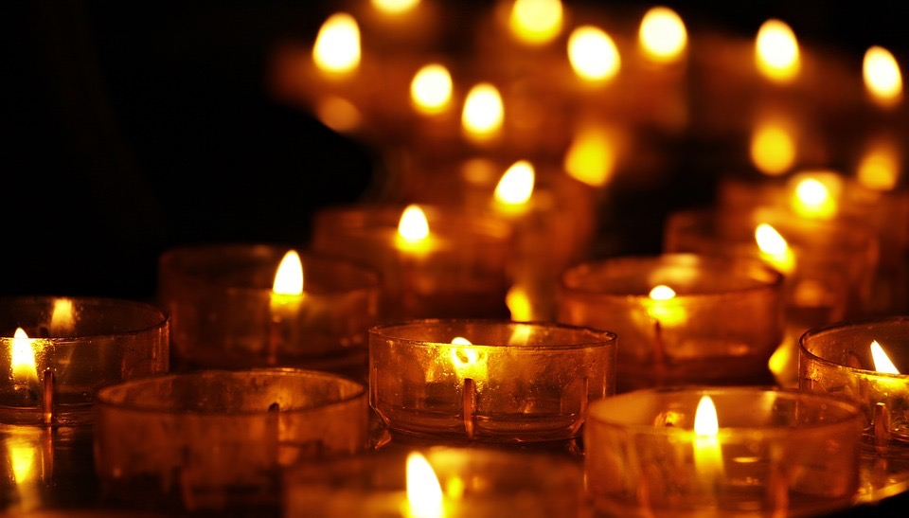
Father Tim has filmed and posted a video where he chats about some of these themes. You can find this week’s Pew Chat here: https://www.youtube.com/watch?v=_qnplO4rD9E

Pray

The Book of Common Prayer is a collection of (you guessed it!) prayers. Try out some new prayers this week. There are some short liturgies in the prayer book called “Daily Devotions for Individuals and Families.” They really are short: just a page long. There’s one for the morning, noonday, evening, and just before bed. They begin on page 136. Try praying one of these this week and maybe fold it into your normal prayer life.

Read from the Bible

Take some time to pray on the themes of leadership in the Bible this week. Here are a few suggested passages, or you can dive into some passages you know and love:

St. Matthew, chapter 3 (Jesus’ baptism)
St. John, 21:15-17 (‘Feed my sheep’)
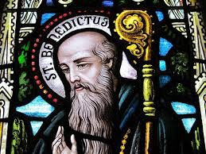
1 Timothy 3:1-12, 5:17-22 (the orders of the Church)

Reflections

St. Benedict teaches that our life as Christians should move between work and prayer (ora et labora). This is some good advice. As you do the work of thinking, reading, and learning, take some time for reflection as well. Sit with God in silence and just listen. Or, if you’re a musical person, here are some suggestions of music to listen to. However you reflect, let go and allow the Spirit to fill you.

Bach Cello Suite
1 - Yo Yo Ma https://www.youtube.com/watch?v=1prweT95Mo0
3 - Yo Yo Ma https://www.youtube.com/watch?v=xR4IElye7eg
4 - Yo Yo Ma https://www.youtube.com/watch?v=JJk2RxGad5o

